Tanzania

## GNI per capita and development level

The data set shows the GNI per capita and development level of the country each year.

## # A tibble: 19 x 5  
## country iso3c date GNIperCapita devCategory  
## <chr> <chr> <dbl> <dbl> <chr>   
## 1 Tanzania TZA 1996 483. Low Income   
## 2 Tanzania TZA 1998 496. Low Income   
## 3 Tanzania TZA 2000 517. Low Income   
## 4 Tanzania TZA 2002 558. Low Income   
## 5 Tanzania TZA 2003 576. Low Income   
## 6 Tanzania TZA 2004 601. Low Income   
## 7 Tanzania TZA 2005 625. Low Income   
## 8 Tanzania TZA 2006 659. Low Income   
## 9 Tanzania TZA 2007 676. Low Income   
## 10 Tanzania TZA 2008 696. Low Income   
## 11 Tanzania TZA 2009 712. Low Income   
## 12 Tanzania TZA 2010 730. Low Income   
## 13 Tanzania TZA 2011 763. Low Income   
## 14 Tanzania TZA 2012 777. Low Income   
## 15 Tanzania TZA 2013 804. Low Income   
## 16 Tanzania TZA 2014 832. Low Income   
## 17 Tanzania TZA 2015 855. Low Income   
## 18 Tanzania TZA 2016 884. Low Income   
## 19 Tanzania TZA 2017 915. Low Income

## GDP growth and economic growth classification

The data set shows the GDP growth and the ecomic growth classification of the country each year.

## # A tibble: 19 x 5  
## country iso3c date GDPannualGrowthRate GDPgrowthCategory4  
## <chr> <chr> <dbl> <dbl> <fct>   
## 1 Tanzania TZA 1996 4.54 moderate growth   
## 2 Tanzania TZA 1998 3.71 moderate growth   
## 3 Tanzania TZA 2000 4.52 moderate growth   
## 4 Tanzania TZA 2002 7.09 fast growth   
## 5 Tanzania TZA 2003 6.67 fast growth   
## 6 Tanzania TZA 2004 7.50 fast growth   
## 7 Tanzania TZA 2005 7.48 fast growth   
## 8 Tanzania TZA 2006 6.53 fast growth   
## 9 Tanzania TZA 2007 6.77 fast growth   
## 10 Tanzania TZA 2008 5.69 fast growth   
## 11 Tanzania TZA 2009 5.27 moderate growth   
## 12 Tanzania TZA 2010 6.34 fast growth   
## 13 Tanzania TZA 2011 7.67 fast growth   
## 14 Tanzania TZA 2012 4.50 moderate growth   
## 15 Tanzania TZA 2013 6.78 fast growth   
## 16 Tanzania TZA 2014 6.73 fast growth   
## 17 Tanzania TZA 2015 6.16 fast growth   
## 18 Tanzania TZA 2016 6.87 fast growth   
## 19 Tanzania TZA 2017 6.79 fast growth

## Development trend

The plot shows the development trend of the country.

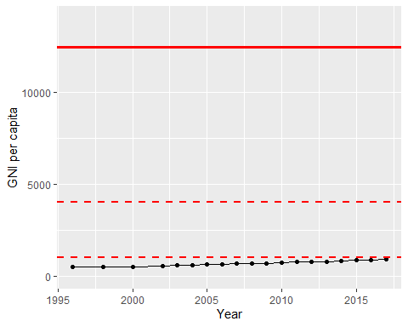

GNI Per Capita Trend